**Министерство науки и высшего образования Российской Федерации Федеральное государственное бюджетное образовательное учреждение высшего образования**

**«Московский государственный технический университет имени Н.Э. Баумана**

**(национальный исследовательский университет)» (МГТУ им. Н.Э. Баумана)**

**Факультет «Информатика и системы управления» Кафедра ИУ5 «Системы обработки информации и управления»**

Лабораторная работа №6

По курсу «Сети и телекоммуникации»

**«Изучение принципов работы утилит для исследования и мониторинга состояния сети»**

**Вариант 18**

Выполнил: студент группы ИУ5-55Б

Шакиров Т.М.

Проверил: Антонов А. И.

2024 г.

Цель работы:

Получение базовых навыков по использованию основных сетевых утилит, применяемых для исследования и мониторинга состояния сети. Изучение принципов их работы.

Ход работы:

1. Просмотреть параметры сетевого интерфейса лабораторного ПК, воспользовавшись утилитой ifconfig. Выведенную на экран информацию сохранить для отчёта.

Использую команду ifconfig, чтобы просмотреть параметры сетевого интерфейса и сохраню вывод в файл network_info.txt с помощью tee.

ifconfig | tee network_info.txt

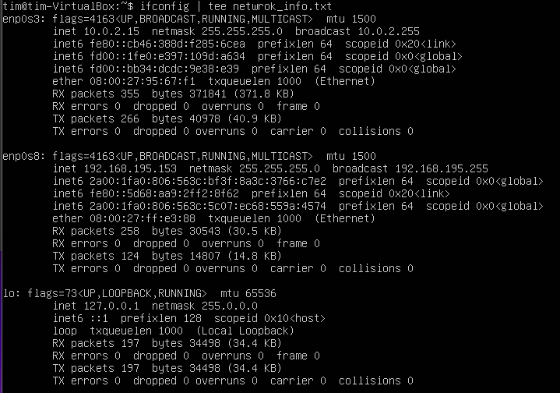

Рисунок. 1

1. С помощью утилиты ping проверить состояние связи с узлами, заданных в таблице 1

Таблица. 1

Чтобы проверить связь с конкретными узлами, использую команду ping,

ограничивая количество отправляемых пакетов 4. ping -c 4 linux.org.ru | tee ping_linux.txt

ping -c 4 www.skype.com| tee ping_skype.txt

ping -c 4 www.runtu.org| tee ping_runtu.txt

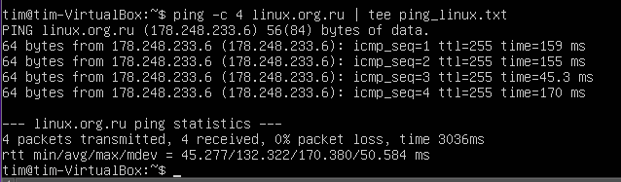

Рисунок 2.

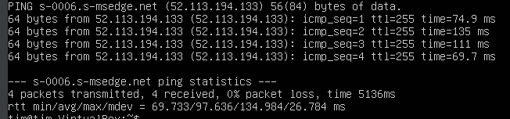

Рисунок 3.

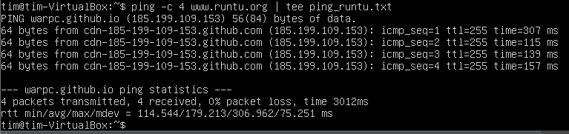

Рисунок 4.

Заполним таблицу:

|  |  |  |  |  |  |
| --- | --- | --- | --- | --- | --- |
| Доменное имя | IP-адресс | Страна | Число потерянных запросов | Среднее время прохождения запроса | TTL |
| linux.org.ru | 178.248.233.6 | Россия | 0 | 132,322 ms | 255 |
| www.skype.com | 52.113.194.133 | США | 0 | 97,636 ms | 255 |
| www.runtu.org | 185.199.109.153 | США | 0 | 179,213 ms | 255 |

Таблица. 2

1. При помощи утилиты traceroute произвести трассировку узлов, заданных в таблице 1. Результаты протоколировать в файл.

По результатам трассировки составить графики времени прохождения маршрутизаторов для каждого узла (для 3 пакетов), указать наиболее узкие места в сети.

Используем команду traceroute, чтобы произвести трассировку маршрута к каждому узлу и записать вывод в файл:

traceroute linux.org.ru > traceroute_linux.txt

traceroute www.skype.com >traceroute_skype.txt

traceroute www.runtu.org > traceroute_runtu.txt

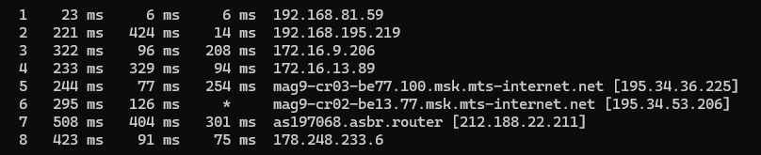

Рисунок 5

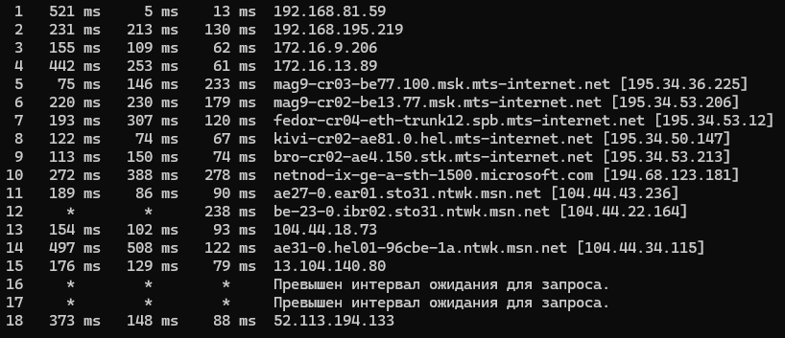

Рисунок 6

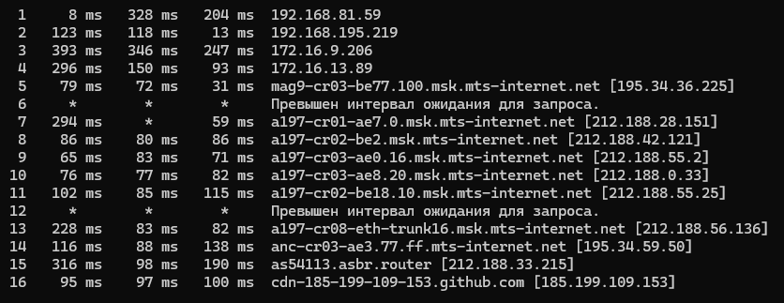

Рисунок 7

После выполнения этих команд создал графики времени прохождения для каждого узла для трёх пакетов, указав узкие места в сети.

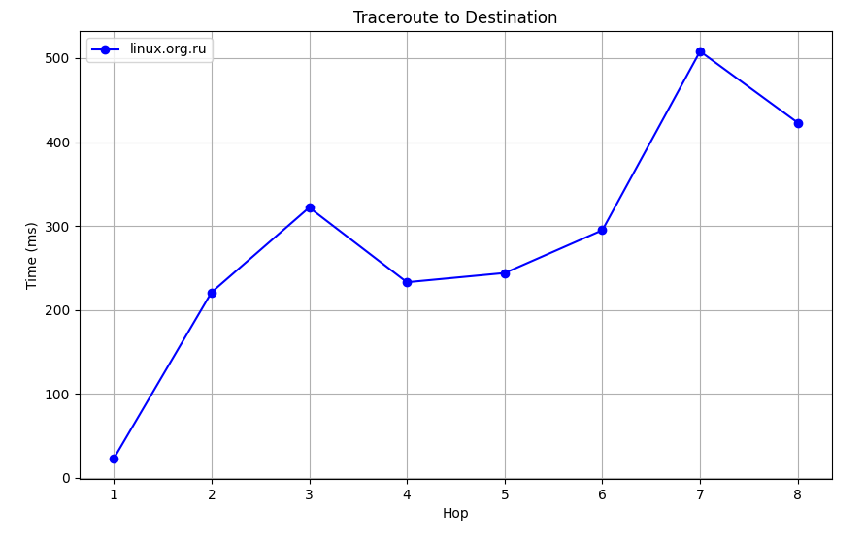

Рисунок 8

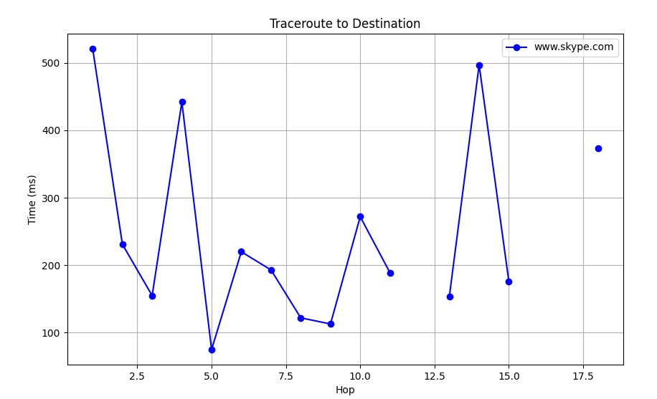

Рисунок 9

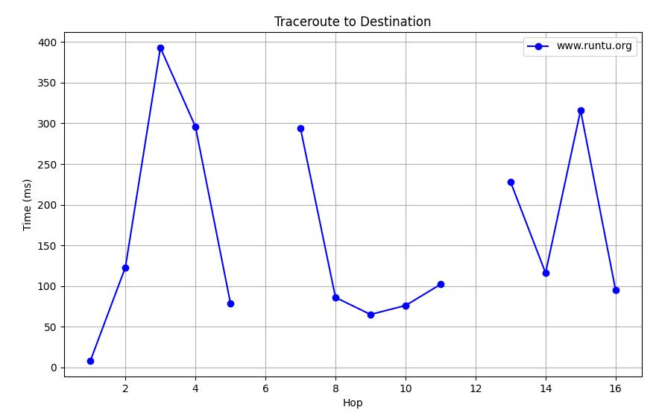

Рисунок 10

1. Получить маршрут прохождения пакетов до одного из заданных в варианте узлов при помощи утилиты ping. Результаты протоколировать в файл.

Чтобы определить маршрут, постепенно увеличивая TTL, выполните следующий цикл:

for ttl in {1..30}; do ping -c 2 -t $ttl linux.org.ru >> ping_trace_linux.txt; done

Эта команда отправляет 2 пакета для каждого значения TTL от 1 до 30 и добавляет результаты в файл ping_trace_linux.txt.

PING linux.org.ru (178.248.233.6) 56(84) bytes of data.

64 bytes from 178.248.233.6: icmp_seq=1 ttl=255 time=160 ms

64 bytes from 178.248.233.6: icmp_seq=2 ttl=255 time=216 ms

--- linux.org.ru ping statistics ---

2 packets transmitted, 2 received, 0% packet loss, time 4350ms

rtt min/avg/max/mdev = 160.499/188.438/216.377/27.939 ms

ping_trace_linux.txt: command not found

ping_trace_linux.txt: command not found

PING linux.org.ru (178.248.233.6) 56(84) bytes of data.

64 bytes from 178.248.233.6: icmp_seq=1 ttl=255 time=169 ms

64 bytes from 178.248.233.6: icmp_seq=2 ttl=255 time=159 ms

--- linux.org.ru ping statistics ---

2 packets transmitted, 2 received, 0% packet loss, time 3413ms

rtt min/avg/max/mdev = 159.479/164.375/169.272/4.896 ms

ping_trace_linux.txt: command not found

ping_trace_linux.txt: command not found

PING linux.org.ru (178.248.233.6) 56(84) bytes of data.

64 bytes from 178.248.233.6: icmp_seq=1 ttl=255 time=303 ms

64 bytes from 178.248.233.6: icmp_seq=2 ttl=255 time=273 ms

--- linux.org.ru ping statistics ---

2 packets transmitted, 2 received, 0% packet loss, time 4124ms

rtt min/avg/max/mdev = 273.156/287.861/302.567/14.705 ms

ping_trace_linux.txt: command not found

ping_trace_linux.txt: command not found

PING linux.org.ru (178.248.233.6) 56(84) bytes of data.

64 bytes from 178.248.233.6: icmp_seq=1 ttl=255 time=239 ms

64 bytes from 178.248.233.6: icmp_seq=2 ttl=255 time=171 ms

--- linux.org.ru ping statistics ---

2 packets transmitted, 2 received, 0% packet loss, time 3866ms

rtt min/avg/max/mdev = 170.923/205.177/239.432/34.254 ms

ping_trace_linux.txt: command not found

ping_trace_linux.txt: command not found

PING linux.org.ru (178.248.233.6) 56(84) bytes of data.

64 bytes from 178.248.233.6: icmp_seq=1 ttl=255 time=714 ms

--- linux.org.ru ping statistics ---

2 packets transmitted, 1 received, 50% packet loss, time 4227ms

rtt min/avg/max/mdev = 714.442/714.442/714.442/0.000 ms

ping_trace_linux.txt: command not found

ping_trace_linux.txt: command not found

PING linux.org.ru (178.248.233.6) 56(84) bytes of data.

64 bytes from 178.248.233.6: icmp_seq=1 ttl=255 time=204 ms

--- linux.org.ru ping statistics ---

2 packets transmitted, 1 received, 50% packet loss, time 5824ms

rtt min/avg/max/mdev = 204.070/204.070/204.070/0.000 ms

ping_trace_linux.txt: command not found

ping_trace_linux.txt: command not found

PING linux.org.ru (178.248.233.6) 56(84) bytes of data.

64 bytes from 178.248.233.6: icmp_seq=1 ttl=255 time=305 ms

64 bytes from 178.248.233.6: icmp_seq=2 ttl=255 time=228 ms

--- linux.org.ru ping statistics ---

2 packets transmitted, 2 received, 0% packet loss, time 6019ms

rtt min/avg/max/mdev = 227.970/266.462/304.954/38.492 ms

ping_trace_linux.txt: command not found

ping_trace_linux.txt: command not found

PING linux.org.ru (178.248.233.6) 56(84) bytes of data.

64 bytes from 178.248.233.6: icmp_seq=1 ttl=255 time=285 ms

64 bytes from 178.248.233.6: icmp_seq=2 ttl=255 time=256 ms

--- linux.org.ru ping statistics ---

2 packets transmitted, 2 received, 0% packet loss, time 4161ms

rtt min/avg/max/mdev = 255.948/270.419/284.891/14.471 ms

ping_trace_linux.txt: command not found

ping_trace_linux.txt: command not found

PING linux.org.ru (178.248.233.6) 56(84) bytes of data.

64 bytes from 178.248.233.6: icmp_seq=1 ttl=255 time=294 ms

64 bytes from 178.248.233.6: icmp_seq=2 ttl=255 time=266 ms

--- linux.org.ru ping statistics ---

2 packets transmitted, 2 received, 0% packet loss, time 4022ms

rtt min/avg/max/mdev = 266.426/280.373/294.320/13.947 ms

ping_trace_linux.txt: command not found

ping_trace_linux.txt: command not found

PING linux.org.ru (178.248.233.6) 56(84) bytes of data.

64 bytes from 178.248.233.6: icmp_seq=1 ttl=255 time=187 ms

64 bytes from 178.248.233.6: icmp_seq=2 ttl=255 time=109 ms

--- linux.org.ru ping statistics ---

2 packets transmitted, 2 received, 0% packet loss, time 4272ms

rtt min/avg/max/mdev = 109.454/148.173/186.893/38.719 ms

ping_trace_linux.txt: command not found

ping_trace_linux.txt: command not found

PING linux.org.ru (178.248.233.6) 56(84) bytes of data.

64 bytes from 178.248.233.6: icmp_seq=1 ttl=255 time=352 ms

64 bytes from 178.248.233.6: icmp_seq=2 ttl=255 time=394 ms

--- linux.org.ru ping statistics ---

2 packets transmitted, 2 received, 0% packet loss, time 4158ms

rtt min/avg/max/mdev = 352.378/373.216/394.054/20.838 ms

ping_trace_linux.txt: command not found

ping_trace_linux.txt: command not found

PING linux.org.ru (178.248.233.6) 56(84) bytes of data.

64 bytes from 178.248.233.6: icmp_seq=1 ttl=255 time=199 ms

64 bytes from 178.248.233.6: icmp_seq=2 ttl=255 time=142 ms

--- linux.org.ru ping statistics ---

2 packets transmitted, 2 received, 0% packet loss, time 4459ms

rtt min/avg/max/mdev = 142.277/170.653/199.030/28.376 ms

ping_trace_linux.txt: command not found

ping_trace_linux.txt: command not found

PING linux.org.ru (178.248.233.6) 56(84) bytes of data.

64 bytes from 178.248.233.6: icmp_seq=1 ttl=255 time=101 ms

64 bytes from 178.248.233.6: icmp_seq=2 ttl=255 time=656 ms

--- linux.org.ru ping statistics ---

2 packets transmitted, 2 received, 0% packet loss, time 4256ms

rtt min/avg/max/mdev = 101.019/378.757/656.495/277.738 ms

ping_trace_linux.txt: command not found

ping_trace_linux.txt: command not found

PING linux.org.ru (178.248.233.6) 56(84) bytes of data.

64 bytes from 178.248.233.6: icmp_seq=1 ttl=255 time=135 ms

64 bytes from 178.248.233.6: icmp_seq=2 ttl=255 time=101 ms

--- linux.org.ru ping statistics ---

2 packets transmitted, 2 received, 0% packet loss, time 4084ms

rtt min/avg/max/mdev = 100.659/117.995/135.331/17.336 ms

ping_trace_linux.txt: command not found

ping_trace_linux.txt: command not found

PING linux.org.ru (178.248.233.6) 56(84) bytes of data.

64 bytes from 178.248.233.6: icmp_seq=1 ttl=255 time=393 ms

64 bytes from 178.248.233.6: icmp_seq=2 ttl=255 time=250 ms

--- linux.org.ru ping statistics ---

2 packets transmitted, 2 received, 0% packet loss, time 4216ms

rtt min/avg/max/mdev = 250.018/321.656/393.295/71.638 ms

ping_trace_linux.txt: command not found

ping_trace_linux.txt: command not found

PING linux.org.ru (178.248.233.6) 56(84) bytes of data.

64 bytes from 178.248.233.6: icmp_seq=1 ttl=255 time=295 ms

64 bytes from 178.248.233.6: icmp_seq=2 ttl=255 time=223 ms

--- linux.org.ru ping statistics ---

2 packets transmitted, 2 received, 0% packet loss, time 4070ms

rtt min/avg/max/mdev = 222.609/258.654/294.699/36.045 ms

ping_trace_linux.txt: command not found

ping_trace_linux.txt: command not found

PING linux.org.ru (178.248.233.6) 56(84) bytes of data.

64 bytes from 178.248.233.6: icmp_seq=1 ttl=255 time=407 ms

64 bytes from 178.248.233.6: icmp_seq=2 ttl=255 time=190 ms

--- linux.org.ru ping statistics ---

2 packets transmitted, 2 received, 0% packet loss, time 4239ms

rtt min/avg/max/mdev = 190.374/298.591/406.809/108.217 ms

ping_trace_linux.txt: command not found

ping_trace_linux.txt: command not found

PING linux.org.ru (178.248.233.6) 56(84) bytes of data.

64 bytes from 178.248.233.6: icmp_seq=1 ttl=255 time=144 ms

64 bytes from 178.248.233.6: icmp_seq=2 ttl=255 time=292 ms

--- linux.org.ru ping statistics ---

2 packets transmitted, 2 received, 0% packet loss, time 4253ms

rtt min/avg/max/mdev = 143.613/217.644/291.675/74.031 ms

ping_trace_linux.txt: command not found

ping_trace_linux.txt: command not found

PING linux.org.ru (178.248.233.6) 56(84) bytes of data.

64 bytes from 178.248.233.6: icmp_seq=1 ttl=255 time=313 ms

64 bytes from 178.248.233.6: icmp_seq=2 ttl=255 time=372 ms

--- linux.org.ru ping statistics ---

2 packets transmitted, 2 received, 0% packet loss, time 4320ms

rtt min/avg/max/mdev = 312.609/342.489/372.370/29.880 ms

ping_trace_linux.txt: command not found

ping_trace_linux.txt: command not found

PING linux.org.ru (178.248.233.6) 56(84) bytes of data.

64 bytes from 178.248.233.6: icmp_seq=1 ttl=255 time=104 ms

64 bytes from 178.248.233.6: icmp_seq=2 ttl=255 time=583 ms

--- linux.org.ru ping statistics ---

2 packets transmitted, 2 received, 0% packet loss, time 4324ms

rtt min/avg/max/mdev = 103.644/343.192/582.740/239.548 ms

ping_trace_linux.txt: command not found

ping_trace_linux.txt: command not found

PING linux.org.ru (178.248.233.6) 56(84) bytes of data.

64 bytes from 178.248.233.6: icmp_seq=1 ttl=255 time=201 ms

64 bytes from 178.248.233.6: icmp_seq=2 ttl=255 time=281 ms

--- linux.org.ru ping statistics ---

2 packets transmitted, 2 received, 0% packet loss, time 4530ms

rtt min/avg/max/mdev = 201.460/241.244/281.028/39.784 ms

ping_trace_linux.txt: command not found

ping_trace_linux.txt: command not found

PING linux.org.ru (178.248.233.6) 56(84) bytes of data.

64 bytes from 178.248.233.6: icmp_seq=1 ttl=255 time=199 ms

64 bytes from 178.248.233.6: icmp_seq=2 ttl=255 time=326 ms

--- linux.org.ru ping statistics ---

2 packets transmitted, 2 received, 0% packet loss, time 4470ms

rtt min/avg/max/mdev = 198.986/262.294/325.602/63.308 ms

ping_trace_linux.txt: command not found

ping_trace_linux.txt: command not found

PING linux.org.ru (178.248.233.6) 56(84) bytes of data.

64 bytes from 178.248.233.6: icmp_seq=1 ttl=255 time=291 ms

64 bytes from 178.248.233.6: icmp_seq=2 ttl=255 time=138 ms

--- linux.org.ru ping statistics ---

2 packets transmitted, 2 received, 0% packet loss, time 4365ms

rtt min/avg/max/mdev = 137.764/214.158/290.552/76.394 ms

ping_trace_linux.txt: command not found

ping_trace_linux.txt: command not found

PING linux.org.ru (178.248.233.6) 56(84) bytes of data.

64 bytes from 178.248.233.6: icmp_seq=1 ttl=255 time=242 ms

64 bytes from 178.248.233.6: icmp_seq=2 ttl=255 time=149 ms

--- linux.org.ru ping statistics ---

2 packets transmitted, 2 received, 0% packet loss, time 4167ms

rtt min/avg/max/mdev = 149.231/195.803/242.376/46.572 ms

ping_trace_linux.txt: command not found

ping_trace_linux.txt: command not found

PING linux.org.ru (178.248.233.6) 56(84) bytes of data.

64 bytes from 178.248.233.6: icmp_seq=1 ttl=255 time=199 ms

64 bytes from 178.248.233.6: icmp_seq=2 ttl=255 time=285 ms

--- linux.org.ru ping statistics ---

2 packets transmitted, 2 received, 0% packet loss, time 4103ms

rtt min/avg/max/mdev = 198.730/241.899/285.069/43.169 ms

ping_trace_linux.txt: command not found

ping_trace_linux.txt: command not found

PING linux.org.ru (178.248.233.6) 56(84) bytes of data.

64 bytes from 178.248.233.6: icmp_seq=1 ttl=255 time=292 ms

64 bytes from 178.248.233.6: icmp_seq=2 ttl=255 time=499 ms

--- linux.org.ru ping statistics ---

2 packets transmitted, 2 received, 0% packet loss, time 4218ms

rtt min/avg/max/mdev = 292.251/395.463/498.675/103.212 ms

ping_trace_linux.txt: command not found

ping_trace_linux.txt: command not found

PING linux.org.ru (178.248.233.6) 56(84) bytes of data.

64 bytes from 178.248.233.6: icmp_seq=1 ttl=255 time=390 ms

--- linux.org.ru ping statistics ---

2 packets transmitted, 1 received, 50% packet loss, time 6489ms

rtt min/avg/max/mdev = 389.540/389.540/389.540/0.000 ms

ping_trace_linux.txt: command not found

ping_trace_linux.txt: command not found

PING linux.org.ru (178.248.233.6) 56(84) bytes of data.

64 bytes from 178.248.233.6: icmp_seq=1 ttl=255 time=1942 ms

64 bytes from 178.248.233.6: icmp_seq=1 ttl=255 time=1942 ms (DUP!)

--- linux.org.ru ping statistics ---

2 packets transmitted, 1 received, +1 duplicates, 50% packet loss, time 1062ms

rtt min/avg/max/mdev = 1941.897/1941.897/1941.898/0.000 ms, pipe 2

ping_trace_linux.txt: command not found

ping_trace_linux.txt: command not found

PING linux.org.ru (178.248.233.6) 56(84) bytes of data.

64 bytes from 178.248.233.6: icmp_seq=1 ttl=255 time=375 ms

64 bytes from 178.248.233.6: icmp_seq=2 ttl=255 time=194 ms

--- linux.org.ru ping statistics ---

2 packets transmitted, 2 received, 0% packet loss, time 8714ms

rtt min/avg/max/mdev = 193.818/284.560/375.302/90.742 ms

ping_trace_linux.txt: command not found

ping_trace_linux.txt: command not found

PING linux.org.ru (178.248.233.6) 56(84) bytes of data.

64 bytes from 178.248.233.6: icmp_seq=1 ttl=255 time=136 ms

64 bytes from 178.248.233.6: icmp_seq=2 ttl=255 time=212 ms

--- linux.org.ru ping statistics ---

2 packets transmitted, 2 received, 0% packet loss, time 3403ms

rtt min/avg/max/mdev = 135.666/173.627/211.588/37.961 ms

ping_trace_linux.txt: command not found

ping_trace_linux.txt: command not found

Определить маршрут прохождения пакетов до узла, выбранного в предыдущем пункте при помощи утилиты mtr. Результаты протоколировать в файл.

Будем использовать WinMTR

|------------------------------------------------------------------------------------------|

| WinMTR statistics |

| Host - % | Sent | Recv | Best | Avrg | Wrst | Last |

|------------------------------------------------|------|------|------|------|------|------|

| 192.168.195.219 - 0 | 97 | 97 | 4 | 32 | 315 | 34 |

| 172.16.9.206 - 0 | 97 | 97 | 28 | 163 | 470 | 300 |

| 172.16.13.89 - 0 | 97 | 97 | 25 | 163 | 472 | 287 |

| mag9-cr03-be77.100.msk.mts-internet.net - 0 | 97 | 97 | 28 | 164 | 466 | 262 |

| mag9-cr02-be13.77.msk.mts-internet.net - 42 | 36 | 21 | 0 | 121 | 512 | 96 |

| as197068.asbr.router - 0 | 97 | 97 | 38 | 168 | 467 | 277 |

| 178.248.233.6 - 0 | 97 | 97 | 23 | 165 | 466 | 275 |

|________________________________________________|______|______|______|______|______|______|

WinMTR v0.92 GPL V2 by Appnor MSP - Fully Managed Hosting & Cloud Provider

Построить графическую карту трассировки одновременно ко всем заданным в таблице 1 узлам при помощи программы tracemap.

для визуализации маршрутов использую Python и библиотеки Graphviz.

Рисунок. 16

Вывод: научился использовать основных сетевые утилиты, применять их для исследования и мониторинга состояния сетей.